Kubernetes Real-Time Interview Questions

Question: Explain about Kubernetes Building Blocks or K8S Architecture?
Question: Explain about Kubernetes Master Architecture or Components?
Question: Explain about Kubernetes Slave/Nodes Architecture or Components?

Answer: Kubernetes mainly used for managing containers and it is also called as container orchestration. Basic Architecture of Kubernetes starts with
Kubernetes Cluster. Cluster is responsible to create Kubernetes Master and then master communicates with Nodes.

Kubernetes Cluster contains 2 components: (Master & Slave/Nodes/Minions)
- Master → It controls and manages a set of worker nodes.
- Node → It manages the Pods and the containers running on a Cluster.

Kubernetes Master Architecture contains 4 Components:
(API-Server + Scheduler + ETCD + Controller Manager)
- API Server → Communicates between Cluster & Master
- Scheduler → Communicates between Master & Slave Nodes
- ETCD → Contains Key-Value Pair which maintains Cluster & Master metadata info.
- Controller Manager → This mainly manages Nodes (i.e. Pods & Containers) and acts as a Deamon Set.

Kubernetes Nodes Architecture contains 3 Components:
(Kube-Proxy + Kubelet + Container)
- Kube-Proxy → Communicates between Node-to-Node & Pod-to-Pod.
- Kubelet → Communicates with Master & maintains Nodes Metadata information.
- Container/Docker → Using Docker we create and deploy applications on Containers.

After this, as a DevOps developer we are responsible to create PODS in Kubernetes, these PODS are nothing but Creating Containers. Using Service.yaml files we can create containers/pods.

Similarly, for deploying any application on Kubernetes, we need 3 mandatory files.
Those are nothing but Service.yaml, Deployment.yaml & Ingress.yaml (Optional)

Kubernetes Architecture & Components in the below diagram for reference.
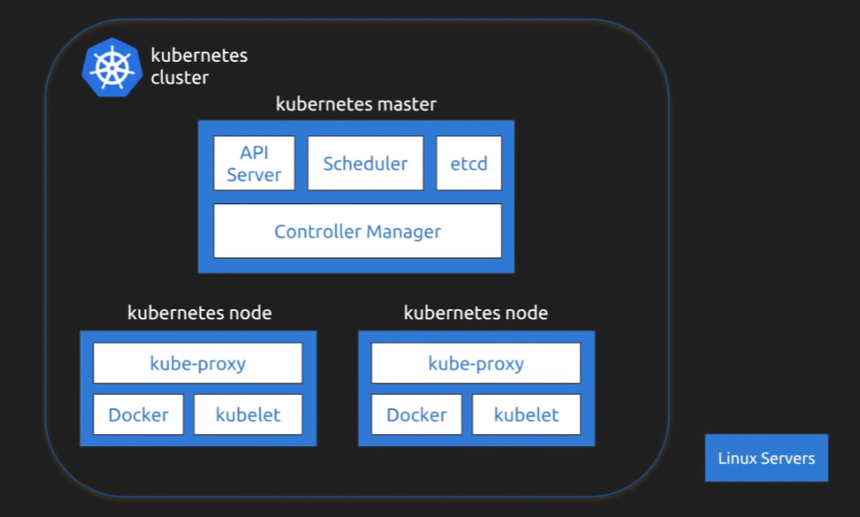

Question: What are PODS in K8S and its benefits?

Answer: POD helps us to create containers, configure containers & deploy the containers on Nodes. In general, POD is nothing but a CONTAINER/SERVER.

- Every NODE, we can have atleast one POD or also multiple PODS.
- Every POD, we can have atleast one application deployed or multiple applications can be deployed on containers.

Kubernetes PODS and its components in the below diagram for reference.

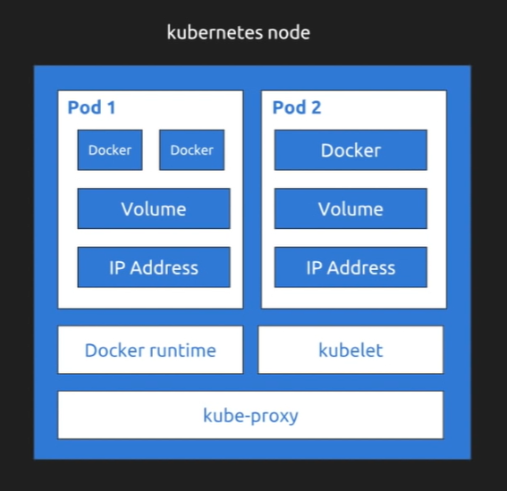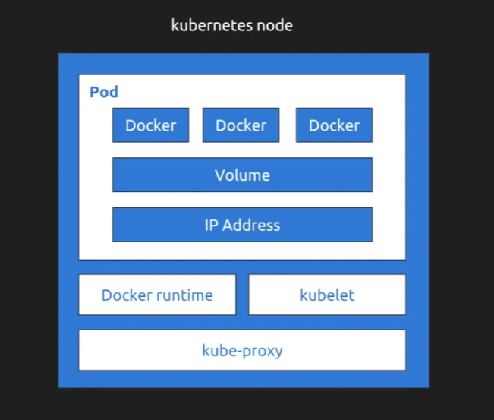

Question: How to create a POD in K8S?

Answer: POD helps us to create containers, configure containers & deploy the containers on Nodes. In general, POD is nothing but a CONTAINER/SERVER.

By using Kubernetes Objects and with YAML files, we can create PODS (i.e. Containers). Refer below format of YAML file for creating POD for reference

Command: kubectl create –f service-pod. Yaml (Command for Creating POD)

Service-pod.yaml example in the below diagram for reference.

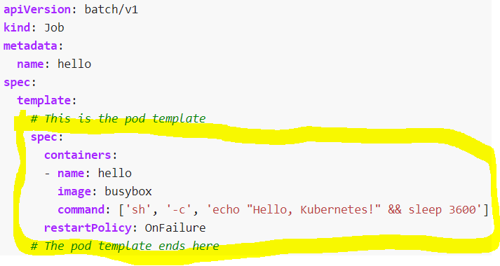

Question: How to handle load balancing in Kubernetes?

Answer: By using Replication Controller & ReplicaSets we can do load balancing.
Load Balancing is nothing but when one POD/Container suddenly DOWN/Stopped then immediately another replica pod will be UP. If a pod stops or dies, the Replication
Set or Replication Controller will create another one to replace it.

Refer below format of YAML file for reference, how to mention ReplicaSets for enabling Load Balancing in K8S.

replicaset-pod.yaml example in the below diagram for reference.

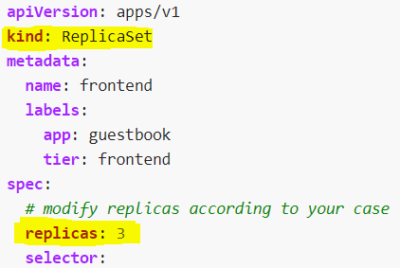

Question: Difference between Liveness Probes & Readiness Probes in K8S?

Answer:
Both liveness & readiness probes are used to control the health of an application. Liveness Probe: Failing Liveness Probe will restart the container.
Readiness Probe: Failing Readiness Probe will stop our application from serving traffic.

liveness-pod.yaml & readiness-pod.yaml example in below diagram for reference

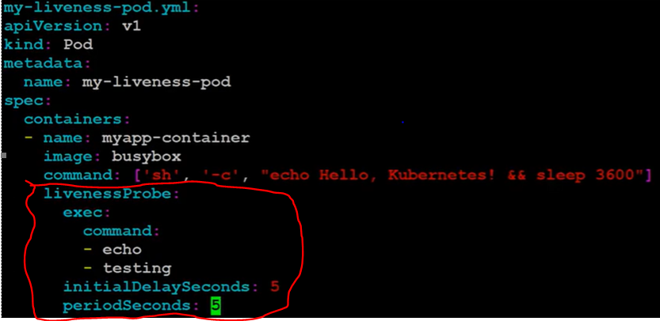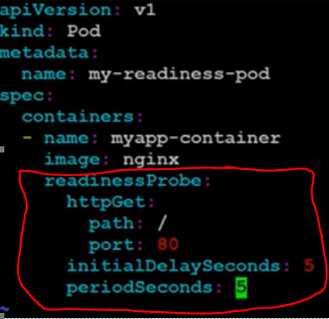

Question: Explain about Kubernetes Components?

- Interviewer can ask anyone of the below as an interview question.

Answer:
Kubernetes Cluster: A Kubernetes cluster is a set of node machines for running containerized applications. If you are running Kubernetes, you're running a cluster.
Head of the K8S family, which holds and manages Master & Slave Nodes information.

Kubernetes Master: A master node is a node which controls and manages a set of worker nodes. In simple, it manages Nodes and its information and finally communicates with K8S Cluster.

Kubernetes Nodes: It manages the Pods and the containers running on a Cluster. A Node is a worker machine in Kubernetes and may be either a virtual or a physical machine, depending on the cluster. Each Node is managed by the Master. Kubelet is a process responsible for communication between the Kubernetes Master and the Node,

API-Server: Communicates between Kubernetes Cluster & Kubernetes Master.

Scheduler: Communicates between Kubernetes Master & Kubernetes Slave/Nodes/Minions.

ETCD: Contains Key-Value Pair which maintains Cluster & Master metadata info.

Controller Manager: Managing nodes and holds its information. This acts like a Deamon.

Kube-Proxy: Communicates between Nodes & Pods. And also performs Load Balancing.
Kube-Proxy mainly used to communicate between Node-to-Node & also communicates between internal PODS too. Also performs load balancing across Pods for a Service. kube-proxy is a network proxy that runs on each node in K8S Cluster.

Kubelet: Communicates with master API-Server & contains Nodes metadata information.

Container: Using Docker we can create and deploy applications on containers.

Kube-System: This acts like a K8S mini database which contains default data of Kubernetes like Secrets, Tokens and etc. The kube-system namespace is used for Kubernetes components managed by Kubernetes

Kubeadm: This is a Tool and mainly used to create Kubernetes Clusters.

Kubectl: This is an CLI (Command Line Interface) used to run the Kubernetes Commands for deploying the application on container.

Question: Explain about Kubernetes Objects?

- Interviewer can ask anyone of the below as an interview question

Answer: Kubernetes objects are persistent entities in the Kubernetes system. List of K8S Objects are mentioned below.

PODS: POD is a small unit used to create & configure containers on Nodes. In general, POD is nothing but a CONTAINER. Containers are previous called as “SERVERS” (Example: Tomcat Server, WebLogic Server, JBOSS, WebSphere). Now in place of SERVERS, we started using Containers.

Namespaces: Helps to communicate between Pod-to-Pod using the same namespace.
This is like a reference to search the PODS with unique identity.

Replication Controller: Manages multiple PODS & able to delete multiple PODS in K8S.
Mainly used to create multiple copies of the same pod (Load Balancing). If a pod stops or dies, the Replication Controller creates another one to replace it. Deleting a DaemonSet will clean up the Pods it created.

Deployment Controller: Manages PODS/Containers Deployment and deploys PODS on containers.

Stateful Sets: Manages any DB related data which is persistent data.

Deamon Sets: Mainly used to manage the containers & images on same NODE or different NODES. This is helpful in situations where you want to run a monitoring or logging application on the nodes in the cluster.

Replica Sets: The Replica Set is the replacement for the Replication controller. They both perform the same functions. However, the Replica Set is much more powerful than the replication controller. If a pod stops or dies, the Replication Set creates another one to replace it.

Services: Which defines about set of PODS & Configure Pods by using Service.yaml file

Config Maps: ConfigMaps are used to separate configuration data from containers in your Kubernetes application. They offer you the ability to dynamically change data for containers at runtime. It’s important to note that ConfigMaps are meant to be used for storing sensitive information. If the data you want to pass to your application is sensitive, then it is recommended you use Secrets instead.

Volumes: Acts as a Storage data and holds data of PODS.
→Persistent Volumes & Persistent Volume Claims (PV & PVC)

Question: Explain about Deployment Process in K8S for deploying application?
Question: Explain about Deployment Steps in K8S for deploying any application?

Answer: Steps to deployment process an application in Kubernetes.
- Client/Developer/DevOps Engineer creates a Kubernetes YAML files.
- Create PODS, Services & Deployments with yaml files by using Create/Apply Commands.
- Service.yaml file creates PODS & Deployment.yaml file creates deployments.
- Then Expose port number for communication between application & kubernetes through TYPE=LoadBalancer/NodePort/ClusterIP/Ingress.
- To check the information about K8S Objects (PODS, Services & etc.) use GET command.
- Once ports are exposed then finally hit the URL EndPoint (http://localhost:8080) in browser to check the application page loaded or not.

Answer: For deploying an application in K8S, we require yaml files like Service.yaml & Deployment.yaml files and Ingress.yaml file for network communication, we can see deployment through K8S Commands.

// To create a service/deployment files use CREATE or APPLY commands.
kubectl create -f service-pod.yaml (OR) kubectl apply -f service-pod.yaml

// To create a deployment file on Kubernetes from docker hub
kubectl create deployment docker-demo --image=gvsridhardevops/docker-demo --port=8082

// To expose port for communicating between docker & Kubernetes through LoadBalancer
kubectl expose deployment docker-demo --type=LoadBalancer --name=shopfront-service

// To get LoadBalancing PODS
kubectl get replicasets

// To know about PODS information
kubectl describe replicasets

// To run the application using Exernal_IP
kubectl get services service-pod

// To get list of deployments in Kubernetes
kubectl get deployments

// To expose port numbers for communicating between docker & Kubernetes
kubectl expose deployment docker-demo --type=NodePort --port=8081

//To run a deployment file on kubernetes from docker hub
kubectl run docker-demo --image=gvsridhardevops/docker-demo --port=8081

// To get list of services in Kubernetes
kubectl get services

// To get list of nodes in Kubernetes
kubectl describe service docker-demo

// To get POD Replicas data - Load Balancing
kubectl scale --replicas=3 deployment/docker-demo

// To delete the service/deployment
kubectl delete service shopfront-service

Question: Differences between Cluster_IP Vs NodePort Vs LoadBalancer?
Question: What are the ServiceTypes in Kubernetes?

Answer: ServiceTypes mainly used for communicating with Ports by using Expose Endpoint.

Cluster_IP (default): Exposes the service on a cluster-internal IP. This type makes the service only reachable from within the cluster. This is the default ServiceType.

NodePort: Exposes the service on each Node’s IP at a static port (the NodePort).
You will be able to contact the NodePort service, from outside the cluster, by requesting → http://<NodeIP>:<NodePort>. (Ex: http://10.121.67.89:31290)
Command: kubectl expose deployment docker-demo --type=NodePort --port=8081

LoadBalancer: Exposes the service externally using an External_IP from localhost. (Ex: http://localhost:9090)
Command: kubectl expose deployment shopfront --type=LoadBalancer --name=service

Ingress: Exposes the service externally using a DNS Name. (Ex: xyz.example.com)

Question: Disadvantages of Kubernetes?

Answer:
- Kubernetes dashboard not as useful as it should be.
- Kubernetes is a little bit complicated and unnecessary in environments where all development is done locally.
- Security is not highly effective.

Question: What is difference between Kubernetes & Docker Swarm?
Kubernetes | Docker Swarm
Enabled default Auto-Scaling | No Auto-Scaling
Automated rollouts & rollbacks | Manual rollouts & rollbacks
Manually configure your load balancing settings | Does auto load balancing
Difficult to start a Cluster | Easy to start a Cluster
Very lightweight which will run any Operating System or Environment. | Very lightweight which will run with default Docker
Dockers native features like Docker Compose are not supported in Kubernetes. | Dockers native features like Docker Compose are supported in Docker Swarm.

Question: Important & Bullet Points in Kubernetes?

Answer:
- Container helps an organization to perform maintenance and update without interrupting services.
- Kubernetes is an example of a container management system developed in the Google platform.
- The biggest advantage of using Kubernetes is that it can run on-premises OpenStack, public clouds Google, Azure, AWS, etc.
- Kubernetes offers automated Scheduling and Self-Healing Capabilities.
- Cluster, master, node, and namespace are important basic of kubernetes.
- Master node and work node are important components of Kubernetes architecture.
- Replication Controllers, Replication sets, Deployments, Stateful Sets, Daemon Sets are other important terms used in Kubernetes.
- Docker swarm does not allow auto-scaling while Kubernetes allows auto-scaling.
- The biggest drawback of Kubernetes is that it's dashboard not very useful and effective.
- Every NODE, we can have atleast one POD or also multiple PODS.
- Every POD, we can have atleast one application deployed or multiple applications can be deployed on containers.

Question: What is Ingress (OR) Ingress Controller in Kubernetes?

Answer: The Ingress controller is acts as an entry point for all incoming traffic (Cluster-To-Cluster, Node-To-Node & Pod-To-Pod) to applications running on Kubernetes. The Ingress controller is an application that runs in a cluster and configures an HTTP load balancer according to Ingress resources.

Question: What is NGINX used for?

Answer: NGINX is open source software for web serving, reverse proxying, caching, load balancing, media streaming, and more.

Question: What is NGINX in Kubernetes?

Answer: The NGINX Ingress Controller for Kubernetes used to manage external load-balancing configuration with the performance, reliability, and advanced features of NGINX and NGINX Plus. Additionally, the NGINX Ingress controller integrates NGINX with cloud-native tools such as Helm and Prometheus, which are rapidly gaining adoption in production Kubernetes environments.

Kubernetes has a built-in configuration for HTTP load balancing, called Ingress, that defines rules for external connectivity to Kubernetes services. The NGINX Ingress Controller for Kubernetes is what enables Kubernetes to configure NGINX & NGINX Plus for load balancing Kubernetes services.

- NGINX mainly used as an Ingress Controller in Kubernetes.
- Using Replica Set & Replication Controllers, we can do Internal Load-Balancing.
- Using NGINX Ingress Controller, we can do External Load-Balancing.

K8S Ingress Tutorial for Beginners: https://www.youtube.com/watch?v=80Ew_fsV4rM

Question: What is Ingress/Egress in Kubernetes? What are advantages of Ingress/Egress?

Answer:
Ingress: From Kubernetes PODS view, Ingress is incoming traffic to the pod
Egress: From Kubernetes PODS view, Egress is outgoing traffic from the pod.

- In Kubernetes network policy, you can create ingress and egress “allow” rules independently (egress, ingress, or both).
- Using NGINX Ingress/Egress Controllers, we can do Outgoing/Incoming External Load-Balancing.

Question: How to create customized secrets in Kubernetes?

Answer: Generally, Kubernetes Secrets are mainly used to store secure and sensitive information like Keys, Passwords & Tokens. In Kubernetes, default Secrets will be stored in Kube-System.

Kubernetes secrets is stored in Base64 Encoding, secrets give you more control over access and usage of passwords, keys, etc. Kubernetes can either mount secrets separately from the pods.

There are many ways to create a Secret:
- create Secret using kubectl command.
- create Secret from config file.
- create Secret using kustomize.

Question: How to enable Auto-Scaling in Kubernetes?

Answer: Autoscaling is one of the key features in Kubernetes cluster. Using Auto-Scaling we are capable of increasing the number of NODES & PODS and decrease the number of NODES & PODS as per the requirement and demand of services in K8S.

Auto-Scaling by default enabled in Kubernetes and also, we can customize Auto-Scaling by 2 ways. (Horizontal Auto-Scaling & Vertical Auto-Scaling)

Horizontal POD Autoscaler: The Horizontal Pod Autoscaler automatically scales the number of Pods in a replication controller, deployment, replica set or stateful set based on observed CPU utilization. Note that Horizontal Pod Autoscaling does not apply to objects that can't be scaled. (Ex: DaemonSets).

Vertical POD Autoscaler: Vertical scaling means raising the resources (like CPU or memory) of each node in the cluster (or in a pool). When it comes to pods though, vertical scaling would mean to dynamically adjust the resource requests and limits based on the current application needs (Vertical Pod Autoscaler).

Command for Auto-Scale:
kubectl autoscale deployment <Application Name> --cpu-percent = 50 --min=1 --max=10

- The above command shows that we will maintain at least one and maximum 10 replica of the POD as the load on the application increases.
Question: What is MINIKUBE?

Answer: Minikube is an open source tool that enables you to run Kubernetes on your laptop or other local machine. It can work with Linux, Mac, and Windows operating systems. It runs a single-node cluster inside a virtual machine on your local machine.

Steps to install MiniKube in our Local Machine
// Install Minikube
cacho install minikube

// Verify that minikube is properly installed
minikube version

// Install Kubernetes-CLI
choco install kubernetes-cli

//Run the command to install Kubectl
curl -LO https://storage.googleapis.com/kubernetes-release/release/v1.10.0/bin/windows/amd64/kubectl.exe

// Start Minikube
minikube start

//VirtualBox Driver Start
minikube start — vm-driver=docker

// Check Minikube status & View Kubernetes Dashboard & view Kubernetes Version
minikube status
minikube dashboard
kubectl version

// View Kubernetes Cluster Information
kubectl cluster-info

// View the nodes that can be used to host your applications
kubectl get nodes

// Create a new deployment
kubectl create deployment hello-nginx --image=nginx --port=80
kubectl run hello-nginx --image=nginx --port=80
kubectl expose deployment hello-nginx --type=NodePort --port=80

// To get the List of Services/Deployments/Nodes/PODS
kubectl get services/deployments/nodes/pods

// To view the details of a specific resource
kubectl describe svc hello-minikube

// To view the URL that you can hit via Browser
minikube service hello-minikube –url

// Delete the service and deployment
kubectl delete service, deployment hello-nginx

// Shut down the Minikube cluster
minikube stop
Question: What is StatefulSet in Kubernetes?

Answer: StatefulSets are used when application state has to be persisted.
Therefore, we use volumeClaimTemplates on persistent volumes to ensure they can keep the state across component restarts. So, if your application is stateful or if you want to deploy stateful storage on top of Kubernetes use a StatefulSet.

A StatefulSet is another Kubernetes controller that manages pods just like Deployments. But it differs from a Deployment in that it is more suited for stateful apps. By nature, a StatefulSet needs persistent storage so that the hosted application saves its state and data across restarts.

Question: What is difference between Statefulset & Deployment (StatelessSet)?

Answer:
StatelessSet: A stateless application is one which depends on NO Persistent Storage. StatefulSet: A stateful application is one which depends on Persistent Storage. There are dynamic databases which, even when the app is offline or deleted, persist on the disk.

Question: What is StatefulSet in Kubernetes?

Answer: StatefulSets are used when application state has to be persisted.
Therefore, we use volumeClaimTemplates on persistent volumes to ensure they can keep the state across component restarts. So, if your application is stateful or if you want to deploy stateful storage on top of Kubernetes use a StatefulSet.

A StatefulSet is another Kubernetes controller that manages pods just like Deployments. But it differs from a Deployment in that it is more suited for stateful apps. By nature, a StatefulSet needs persistent storage so that the hosted application saves its state and data across restarts.

Question: What is difference between Statefulset & Deployment (StatelessSet)?

Answer:
StatelessSet: A stateless application is one which depends on NO Persistent Storage. StatefulSet: A stateful application is one which depends on Persistent Storage. There are dynamic databases which, even when the app is offline or deleted, persist on the disk.

Question: How do we secure Passwords of Database?
How to provide API Security in K8S?

Answer: Using Kube-Secrets & ConfigMap - read more in-depth

Question: Where we specify memory or cpu related things in Kubernetes?

Answer: Mention that in Service/Deployment YAML files - read more in-depth on yaml file examples
Question: What are Kubernetes Deployment Strategies?

Answer: Using Kube-Secrets & ConfigMap - read more in-depth

Question: If POD down, how do we enable other POD?

Answer: By Load Balancing in Kubernetes & Setting ReplicaSet in Yaml file - read more in-depth on yaml file examples.

Question: What are the real-time issues you faced while deploying the applications in Kubernetes?

Answer: Mention ConfigMap issues & Pods related issues like LivenessProbes or ReadinessProbes - read more in-depth.

Question: How to deploy applications with Zero-Downtime in K8S?

Answer: Using HPA (Horizontal Pod Auto-Scaling) or Using Kubernetes Deployment Strategies - read more in-depth

Question: What are Service Types in Kubernetes?

Answer: LoadBalancer/NodePort/ClusterIP - read more in-depth

Question: How to package all the configurations in K8S?

Answer: Using Helm-Charts - read more in-depth

Question: What is NodeGroup in Kubernetes?

Answer: LoadBalancer/NodePort/ClusterIP - read more in-depth

Question: How to provide High Availability (HA) in Kubernetes?

Answer: By creating multiple master agents, we can provide zero downtime - read more in-depth

Question: How to communicate between clusters in Kubernetes?

Answer: By using Ingress Controller and NGINX is default ingress communication controller channel – refer above interview question to know more about ingress & nginx.
Question: What is HPA in Kubernetes?

Answer: Horizontal POD Auto-Scaling can be done by increasing the Limits of the containers & PODS – refer above interview question to know more about ingress & nginx.

Question: What is NODE Affinity, POD Affinity & Session Affinity in Kubernetes?

Answer:
NODE Affinity: Node affinity is a set of rules used by the scheduler to determine where a pod can be placed. Node affinity allows a pod to specify an affinity (or anti-affinity) towards a group of nodes it can be placed on. The node does not have control over the placement.

POD Affinity: Pod affinity and pod anti-affinity allow you to specify rules about how pods should be placed relative to other pods. The rules are defined using custom labels on nodes and label selectors specified in pods.

Session Affinity: Session affinity associates all requests coming from an end-user with a single pod. This means that all traffic from a client to a pod will be directed to the same pod. Session affinity, also known as “sticky sessions”, is the function of the load balancer that directs subsequent requests from each unique session to the same load balancer pool.

Question: What is RBAC Policy in Kubernetes?

Answer:
- RBAC, Role-based access control, is an authorization mechanism for managing
permissions around Kubernetes resources. RBAC allows configuration of flexible authorization policies that can be updated without cluster restarts.
- From Kubernetes 1.6 onwards, RBAC policies are enabled by default. RBAC policies
are vital for the correct management of your cluster, as they allow you to specify which types of actions are permitted depending on the user and their role in your organization.

Question: What is Role Binding in Kubernetes?

Answer:
- A role binding grants the permissions defined in a role to a user or set of users.
It holds a list of subjects (users, groups, or service accounts), and a reference to the role being granted. A Role-Binding grants permissions within a specific namespace whereas a Cluster-Role-Binding grants that access cluster-wide managing

Question: Explain few basic commands in Kubernetes?

Answer:
